[**1539. Kth Missing Positive Number**](https://leetcode.com/problems/kth-missing-positive-number/)

Given an array arr of positive integers sorted in a **strictly increasing order**, and an integer k.

Return the kth ***positive*** integer that is ***missing*** from this array.

brute force

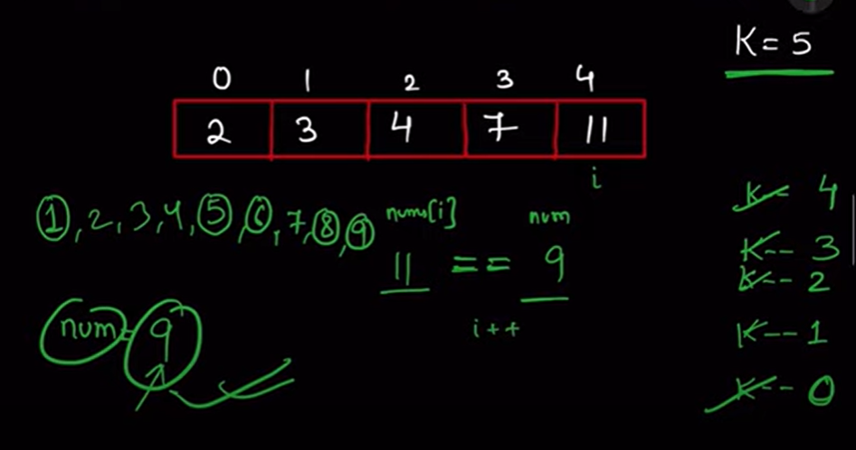

Optimal one

